**SMART FARMER – IoT ENABLED SMART FARMER APPLICATION**

**ASSIGNMENT 2**

|  |  |
| --- | --- |
| **NAME** | **ROLL NO** |
| PRIKSHIT SINGH | 718019L237 |

1. **Build a python code, Assume u get temperature and humidity values(generated with random function to a variable) and a write a condition to continuously detect alarm in case of high temperature.**

**Python Code:**

import random

import time

while(True):

temp=random.randint(0,1024)

print(f'Temperature = {temp}')

if temp>600:

print('Temperatur is high\n ======================== ')

time.sleep(4)

**Editor Window:**

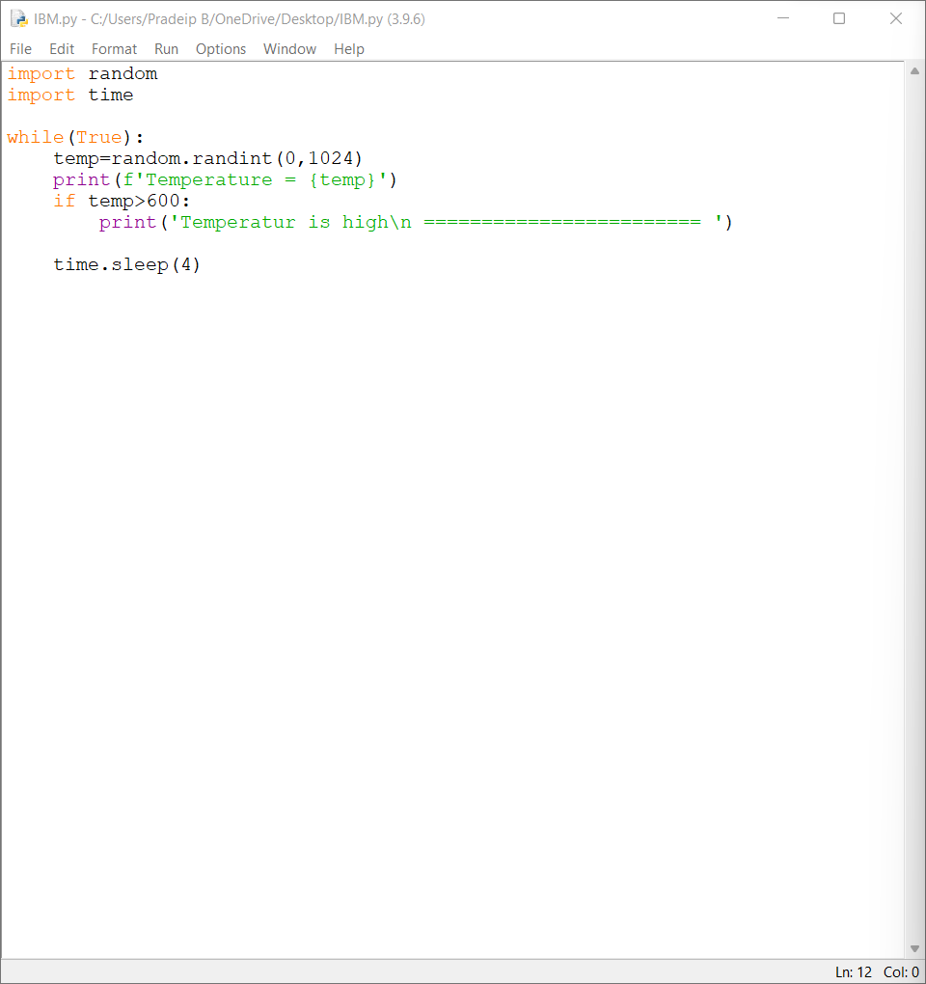

**Output Window:**

